|  |  |
| --- | --- |
| Network Design |  |

**Part 1**

You were just hired at a small company as a network administrator. The previous network administrator quit abruptly and has left no documentation about the network setup. You need to figure out how the various devices of the network are connected with each other and **produce a network diagram with as many details as possible**.

All of the networking devices are rack-mounted, so you cannot physically see what is connected to what. You start your investigation by gathering information from the devices, such as routing tables, ARP tables, and NAT tables. The information you gather is the following:

Routing Tables

Routing Table in R1

|  |  |
| --- | --- |
| **Network Address** | **Interface** |
| 10.0.1.11 | 10.0.1.1 |
| 10.0.0.x | 10.0.1.1 |
| All other addresses | 72.44.116.13 |

Routing Table in R2

|  |  |
| --- | --- |
| **Network Address** | **Interface** |
| 10.0.0.101 | 10.0.0.1 |
| 10.0.0.102 | 10.0.0.1 |
| 10.0.0.103 | 10.0.0.1 |
| 10.0.0.104 | 10.0.0.1 |
| 10.0.1.1 | 10.0.1.11 |
| All other addresses | 10.0.1.11 |

ARP Tables

If a machine wants to send a packet to an IP address that is not in its ARP table, the MAC address will be set to default gateway (next hop router) MAC address.

ARP Table in PC1

|  |  |
| --- | --- |
| **IP Address** | **MAC Address** |
| 10.0.0.1 | AC-CC-D7-99-B2-63 (Default gateway) |
| 10.0.0.101 | A1-B2-C3-D4-E5-F6 (Itself) |
| 10.0.0.102 | F6-E5-D4-C3-B2-A1 |
| 10.0.0.103 | 98-BA-BD-6F-44-3D |
| 10.0.0.104 | 00-B0-D0-63-C2-26 |

ARP Table in PC2

|  |  |
| --- | --- |
| **IP Address** | **MAC Address** |
| 10.0.0.1 | AC-CC-D7-99-B2-63 (Default gateway) |
| 10.0.0.101 | A1-B2-C3-D4-E5-F6 |
| 10.0.0.102 | F6-E5-D4-C3-B2-A1 (Itself) |
| 10.0.0.103 | 98-BA-BD-6F-44-3D |
| 10.0.0.104 | 00-B0-D0-63-C2-26 |

ARP Table in PC3

|  |  |
| --- | --- |
| **IP Address** | **MAC Address** |
| 10.0.0.1 | AC-CC-D7-99-B2-63 (Default gateway) |
| 10.0.0.101 | A1-B2-C3-D4-E5-F6 |
| 10.0.0.102 | F6-E5-D4-C3-B2-A1 |
| 10.0.0.103 | 98-BA-BD-6F-44-3D (Itself) |
| 10.0.0.104 | 00-B0-D0-63-C2-26 |

ARP Table in PC4

|  |  |
| --- | --- |
| **IP Address** | **MAC Address** |
| 10.0.0.1 | AC-CC-D7-99-B2-63 (Default gateway) |
| 10.0.0.101 | A1-B2-C3-D4-E5-F6 |
| 10.0.0.102 | F6-E5-D4-C3-B2-A1 |
| 10.0.0.103 | 98-BA-BD-6F-44-3D |
| 10.0.0.104 | 00-B0-D0-63-C2-26 (Itself) |

ARP Table in R1

|  |  |
| --- | --- |
| **IP Address** | **MAC Address** |
| 128.226.79.123 | FF-B1-37-72-F2-11 (Internet next hop) |
| 72.44.116.13 | 12-B7-38-64-FD-FF (Itself external) |
| 10.0.1.1 | 33-19-2B-22-A4-88 (Itself internal) |
| 10.0.1.11 | 5D-B5-42-55-AB-BA |

ARP Table in R2

|  |  |
| --- | --- |
| **IP Address** | **MAC Address** |
| 10.0.1.1 | 33-19-2B-22-A4-88 (Default gateway) |
| 10.0.1.11 | 5D-B5-42-55-AB-BA (Itself external) |
| 10.0.0.1 | AC-CC-D7-99-B2-63 (Itself internal) |
| 10.0.0.101 | A1-B2-C3-D4-E5-F6 |
| 10.0.0.102 | F6-E5-D4-C3-B2-A1 |
| 10.0.0.103 | 98-BA-BD-6F-44-3D |
| 10.0.0.104 | 00-B0-D0-63-C2-26 |

NAT Table in R1

|  |  |
| --- | --- |
| **WAN** | **LAN** |
| 72.44.116.13, 8000 | 10.0.0.101, 80 |
| 72.44.116.13, 8001 | 10.0.0.101, 443 |
| 72.44.116.13, 8002 | 10.0.0.101, 53 |
| 72.44.116.13, 8003 | 10.0.0.102, 80 |
| 72.44.116.13, 8004 | 10.0.0.102, 443 |
| 72.44.116.13, 8005 | 10.0.0.102, 53 |
| 72.44.116.13, 8006 | 10.0.0.103, 80 |
| 72.44.116.13, 8007 | 10.0.0.103, 443 |
| 72.44.116.13, 8008 | 10.0.0.103, 53 |
| 72.44.116.13, 8009 | 10.0.0.104, 80 |
| 72.44.116.13, 8010 | 10.0.0.104, 443 |
| 72.44.116.13, 8011 | 10.0.0.104, 53 |

**Answers**

The network diagram is the following:



The information of each device in the network is the following:

PC1

IP address: 10.0.0.101

MAC address: A1-B2-C3-D4-E5-F6

PC2

IP address: 10.0.0.102

MAC address: F6-E5-D4-C3-B2-A1

PC3

IP address: 10.0.0.103

MAC address: 98-BA-BD-6F-44-3D

PC4

IP address: 10.0.0.104

MAC address: 00-B0-D0-63-C2-26

Router R1 (internal interface that connects to R2)

IP address: 10.0.1.1

MAC address: 33-19-2B-22-A4-88

Router R1 (external interface that connects to the internet)

IP address: 72.44.116.13

MAC address: 12-B7-38-64-FD-FF

Router R2 (internal interface that connects to the PCs)

IP address: 10.0.0.1

MAC address: AC-CC-D7-99-B2-63

Router R2 (external interface that connects to R1)

IP address: 10.0.1.11

MAC address: 5D-B5-42-55-AB-BA

Next Hop

IP address: 128.226.79.123

MAC address: FF-B1-37-72-F2-11

**Part 2**

This is not related to part 1. You work as an independent contractor and specialize in network design. A client has hired you to design the network of their small company. They gave you a list of must-haves and a list of nice-to-haves. Give them two options (one that includes all the must-haves and one with all the nice-to-haves added). **Give them a shopping list, the total sum, and a network diagram for each solution.**

Must-haves:

* 1 wired printer with a non-upgradable 100Mbps wired NIC.
* 3 wired desktop computers. They are already equipped with 2.5Gbps NICs. The NICs are upgradeable.
* 10 wireless devices (assume that each wireless device has a 1Gbps wireless NIC).
* 2 LANs. The first LAN must include the printer and 2 wired computers. The second LAN must include the third wired computer and all the wireless devices.
* The two wired computers in the first LAN must communicate at 10Gbps or more.
* The wired computers of the two LANs must communicate at 2.5Gbps or more (inter-LAN communication).
* The total wireless bandwidth must be at least 1Gbps. The individual wireless bandwidth can be lower.
* The internet bandwidth of all devices in the company must be at least 1Gbps. The printer does not access the internet.

Nice-to-haves:

* The wired computers of the two LANs can communicate at 10Gbps.
* The total wireless bandwidth should be at least 2.5Gbps. Assume that multiple devices are connected to Wi-Fi at the same time. The individual wireless bandwidth can remain at 1Gbps or less.
* The internet of all wired devices should be at least 2.5Gbps. The printer does not access the internet.

You searched the internet, and you came up with the following available devices, services, and prices:

CAT5e ethernet cable - $10

CAT6 ethernet cable - $15

2.5Gbps wired NIC - $20

10Gbps wired NIC - $30

1Gbps 8-port L2 switch - $30

2.5Gbps 8-port L2 switch - $80

10Gbps 8-port L2 switch - $200

1Gbps 8-port L3 switch - $40

2.5Gbps 8-port L3 switch - $100

10Gbps 8-port L3 switch - $400

1Gbps 4-port router with NAT - $40

2.5Gbps 4-port router with NAT - $160

10Gbps 4-port router with NAT - $530

1Gbps (ethernet), 1Gbps (wireless) WAP - $50

2.5Gbps (ethernet), 1Gbps (wireless) WAP - $120

10Gbps (ethernet), 2.5Gbps (wireless) WAP - $500

1Gbps internet connection - $50

2.5Gbps internet connection - $100

10Gbps internet connection - $200

*For all internet connections, the cable that brings internet to the building is included in the price

**Answers**

For the must-haves there is a $600 solution, which is simpler, and a $590 solution which is more complex. Both are acceptable solutions.

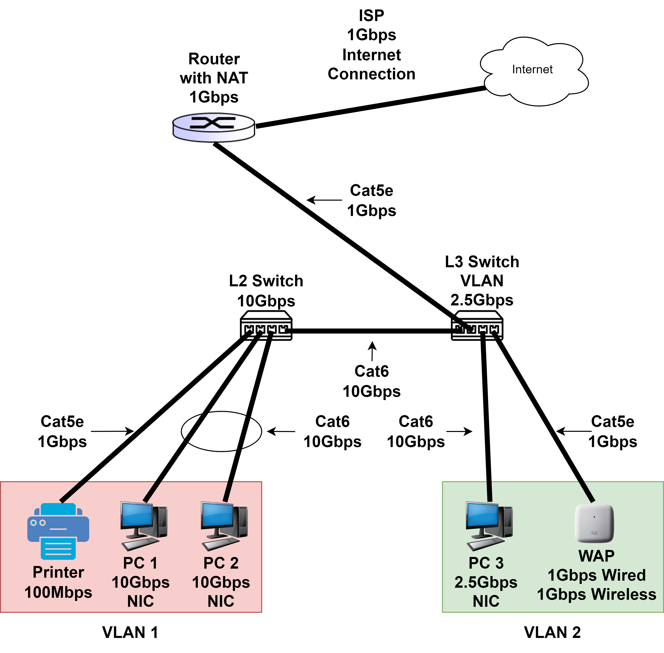

Must-haves parts list (1st solution):

2x 10Gbps wired NIC - $60

1x 10Gbps 8-port L2 switch - $200

1x 2.5Gbps 8-port L3 switch - $100

1x 1Gbps (ethernet), 1Gbps (wireless) WAP - $50

1x 1Gbps 4-port router with NAT - $40

1x 1Gbps internet connection - $50

3x CAT5e ethernet cable - $30

4x CAT6 ethernet cable - $60

Total sum: $590

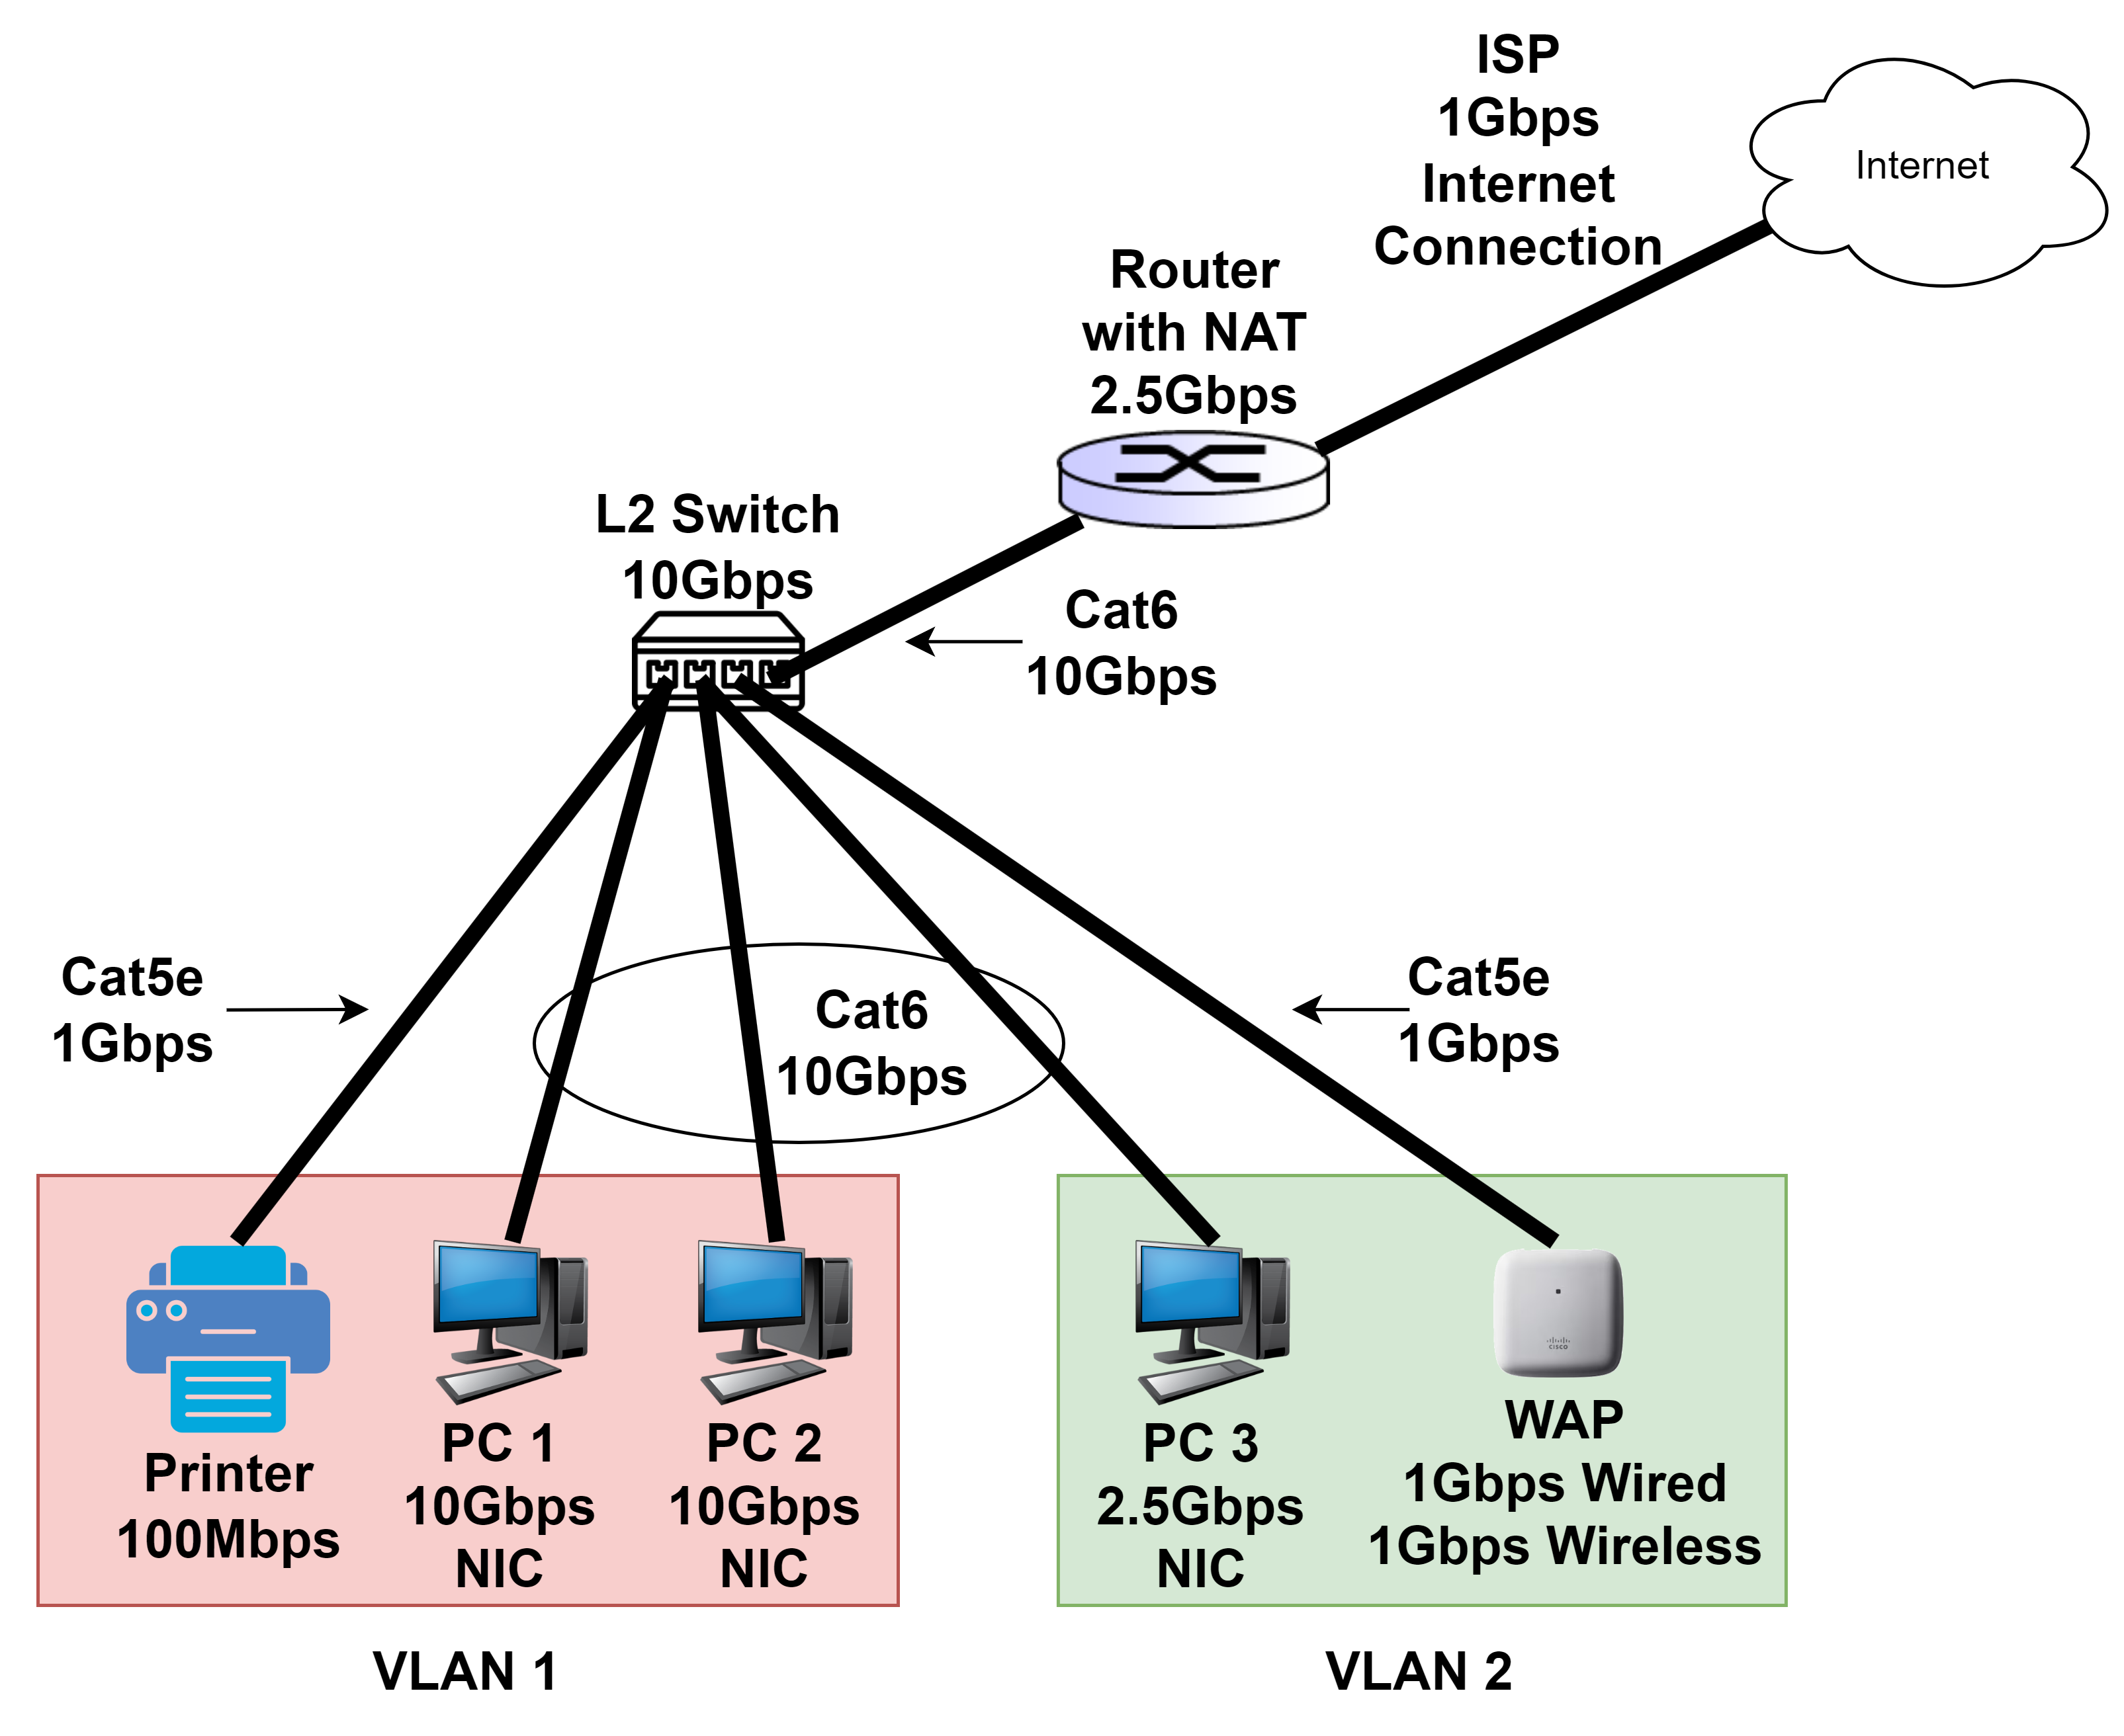

Must-haves parts list (2nd solution):

2x 10Gbps wired NIC - $60

1x 10Gbps 8-port L2 switch - $200

1x 1Gbps (ethernet), 1Gbps (wireless) WAP - $50

1x 2.5Gbps 4-port router with NAT - $160

1x 1Gbps internet connection - $50

2x CAT5e ethernet cable - $20

4x CAT6 ethernet cable - $60

Total sum: $600

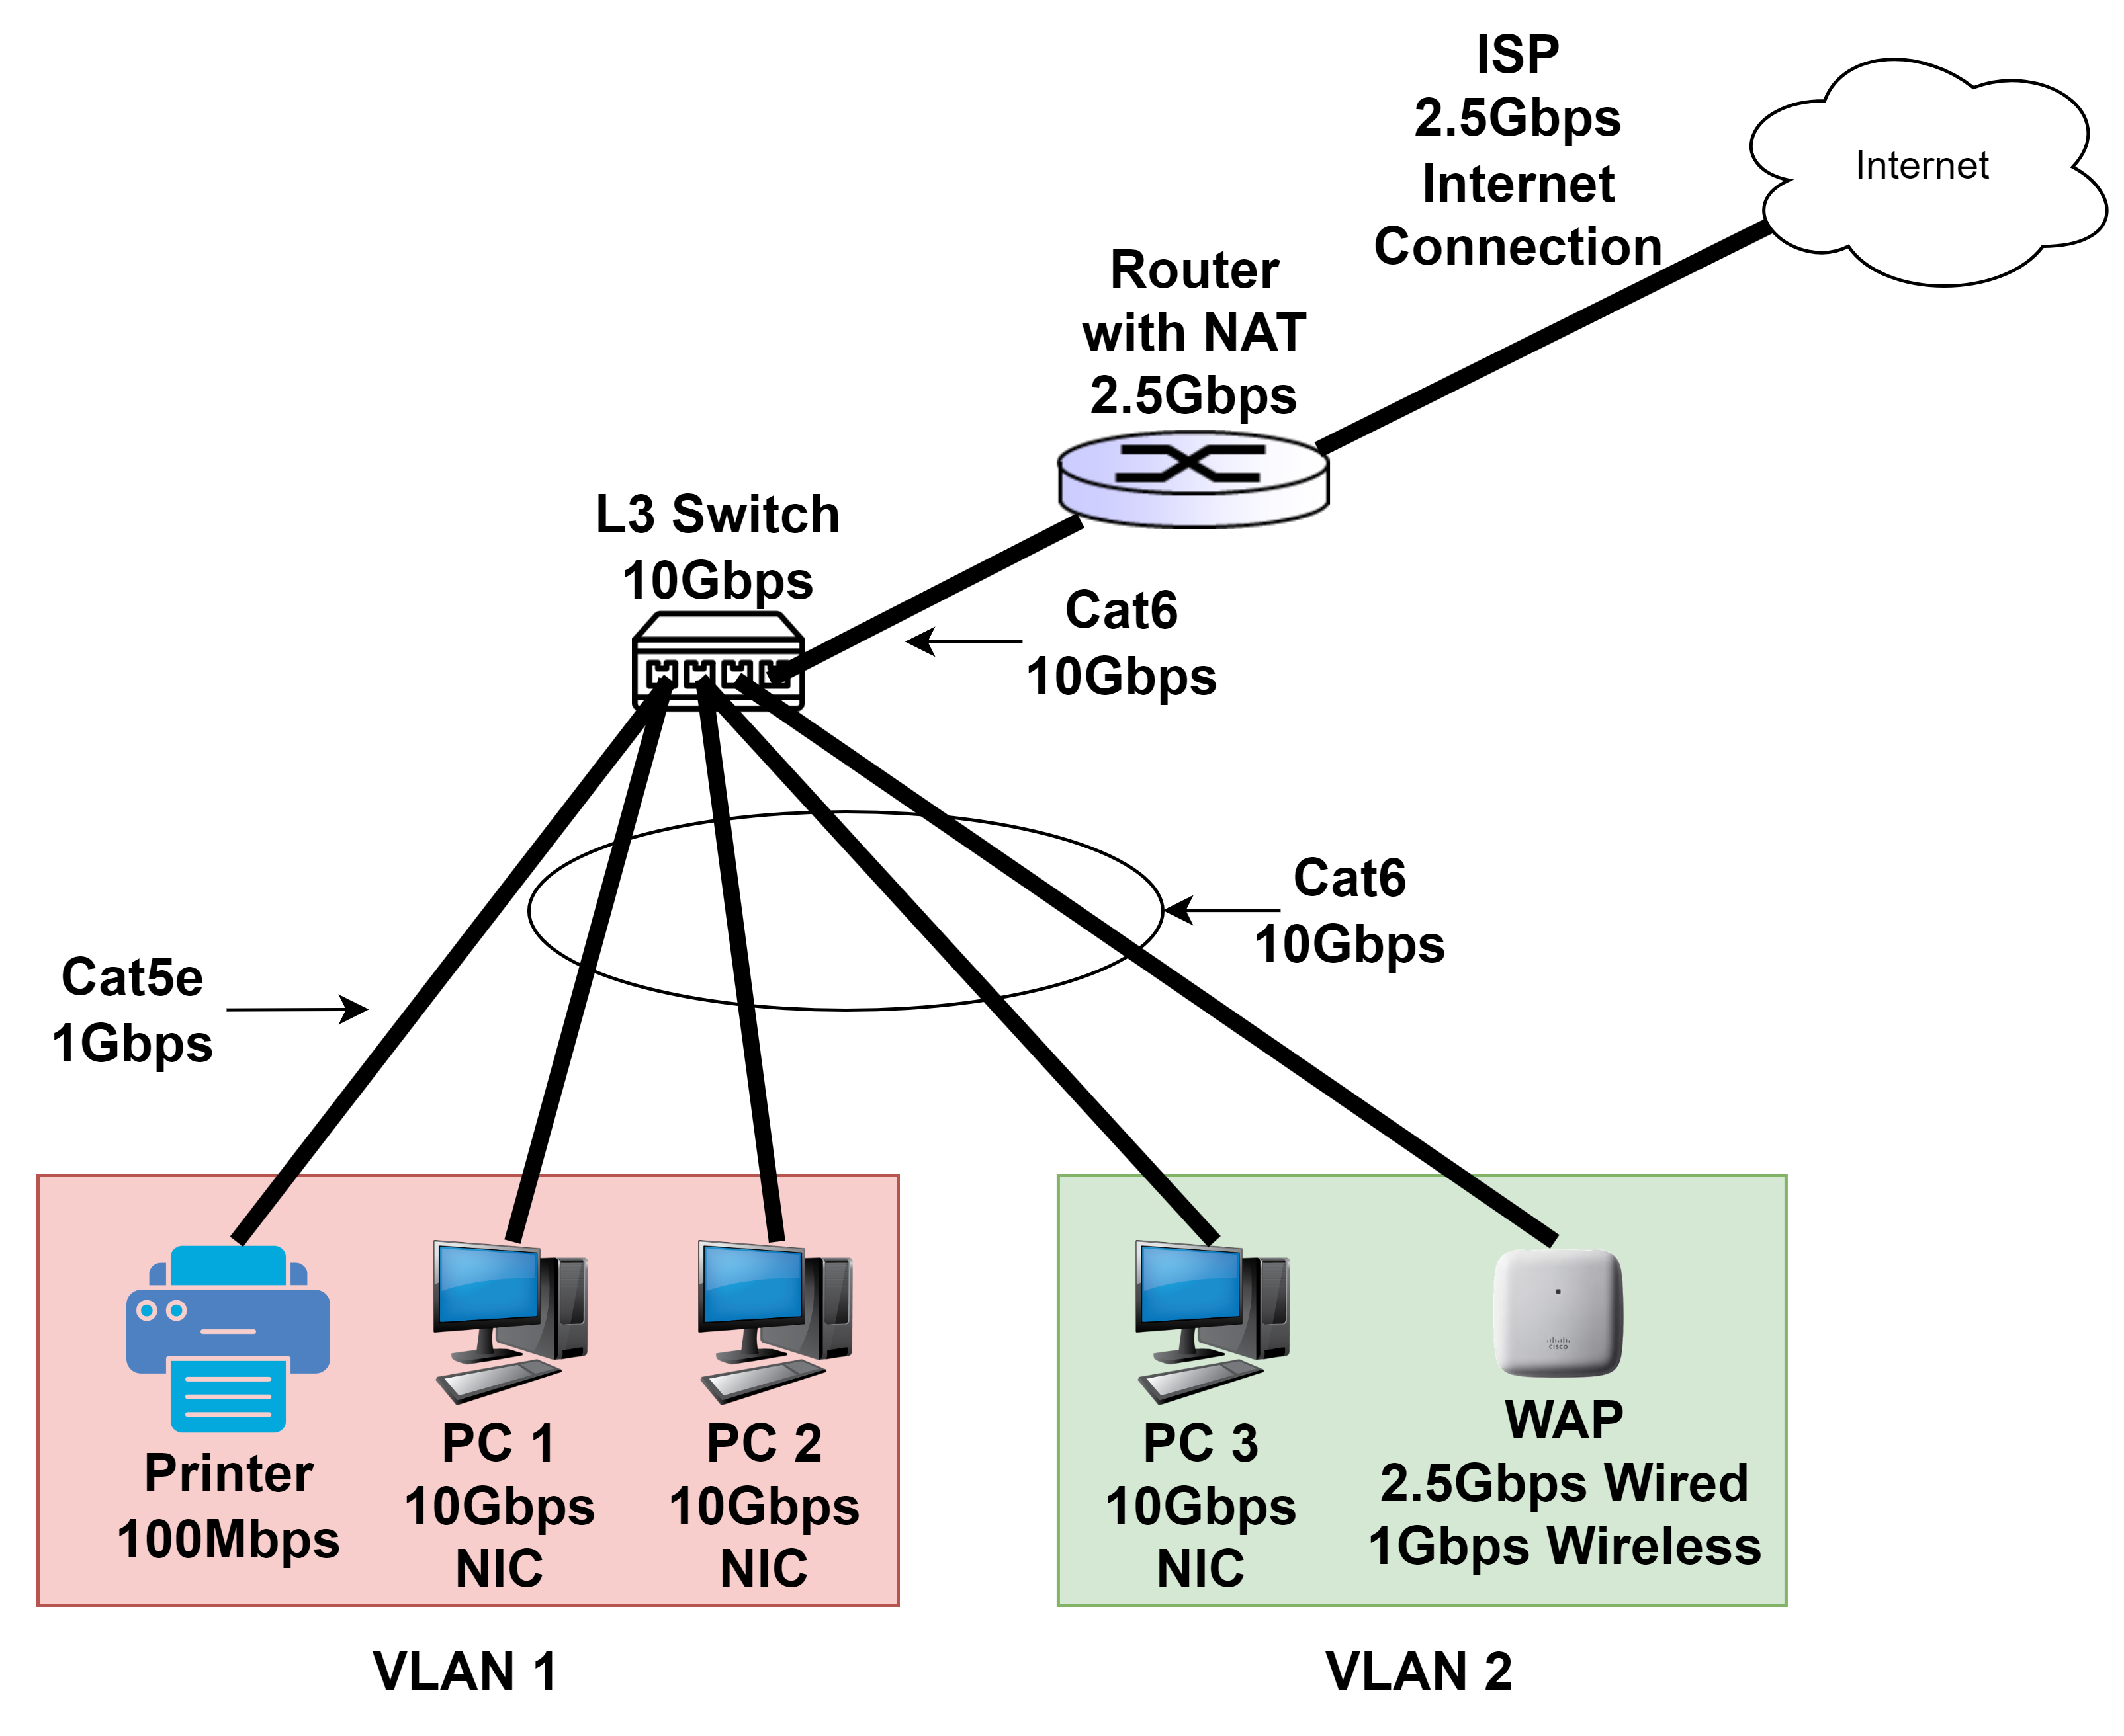

Nice-to-haves parts list:

3x 10Gbps wired NIC - $90

1x 10Gbps 8-port L3 switch - $400

1x 2.5Gbps (ethernet), 1Gbps (wireless) WAP - $120

1x 2.5Gbps 4-port router with NAT - $160 (Cannot use a 10Gbps router and throw away the L3 switch, because the router doesn’t have enough ports)

2.5Gbps internet connection - $100

1x CAT5e ethernet cable - $10

5x CAT6 ethernet cable - $75

Total sum: $955